

Project Overview
This project analyses customer shopping behaviour using Python (EDA), SQL (data analysis), and Power BI (visualization) to uncover insights related to purchasing patterns, customer segmentation, and revenue drivers.
The objective is to:
- Understand customer purchasing habits
- Identify high-value customer segments
- Analyse the impact of discounts and subscriptions
- Generate actionable business insights

Data Summary
The dataset contains customer-level transactional data with the following key features:
- Customer Information: customer_id, gender, age_group
- Purchase Details: item_purchased, category, purchased_amount
- Behavioral Metrics: previous_purchases, subscription_status
- Marketing Factors: discount_applied, shipping_type
- Feedback: review_rating
Key Characteristics:
- Mix of categorical and numerical data
- Includes customer lifecycle indicators
- Useful for segmentation and revenue analysis

Data Cleaning (PYTHON)
The dataset was preprocessed to ensure accuracy, consistency, and reliability before analysis.

Steps Performed:
- Handled Missing Values:
Checked for null values across all columns and removed/handled them to avoid inconsistencies in analysis.
- Data Type Correction:
Ensured that numerical columns such as purchased_amount, review_rating, and previous_purchases were in the correct format for calculations.
- Feature Engineering (Age Grouping):
Created a new column age_group to segment customers into:
  - Young Adult
  - Adult
  - Middle-Age
  - Senior
This helped in better demographic analysis and visualization.
- Data Consistency Checks:
Verified categorical values like gender, subscription_status, and shipping_type to ensure uniformity.

Exploratory Data Analysis (EDA) — SQL-Based
- Customer Demographics
- The Young Adult segment represents the largest portion of customers.
- This group also contributes the highest revenue, making it the most valuable segment.

- Revenue Insights
- The average purchase amount is $59.76, indicating moderate spending behaviour.
- Revenue varies significantly across categories, with Clothing generating the highest revenue.

- Discount Behaviour
- Customers who used discounts often made purchases above average value.
- However, discounts tend to increase purchase frequency more than individual transaction value.

- Subscription Analysis
- Majority of customers are non-subscribers.
- However, subscribed customers contribute higher average spending and total revenue, indicating higher customer lifetime value.

- Shipping Insights
- Standard and Express shipping were compared.
- Customers opting for faster shipping methods tend to have slightly higher purchase amounts.

- Product Performance
- Top-rated products were identified using average review ratings.
- Certain products consistently rank higher, indicating strong customer satisfaction and demand.

- Customer Segmentation
- Customers were segmented into:
- New
- Returning
- Loyal
- Loyal customers (high previous purchases) form a smaller group but contribute significantly to revenue.

- Top Products by Category
- Identified top 3 products in each category using ranking functions.
- Helps in inventory and marketing optimization.
- Repeat Buyers vs Subscription
- Repeat buyers (more than 5 purchases) show a strong tendency toward subscription plans.
- Indicates potential for upselling subscription services.

- Revenue by Age Group
- Young Adults contribute the most revenue
- Followed by Middle-Age and Adults
- Seniors contribute the least

Summary of Analysis
- Young Adults are the core customer segment
- Subscription increases customer value
- Discounts influence buying behaviour
- Loyal customers drive long-term revenue
- Product/category performance varies significantly

Dashboard Overview (POWER BI)
The Power BI dashboard provides an interactive view of customer purchasing behaviour, enabling quick identification of trends, patterns, and key business metrics.
It consolidates multiple dimensions such as revenue, customer demographics, product categories, and subscription behaviour into a single analytical view.

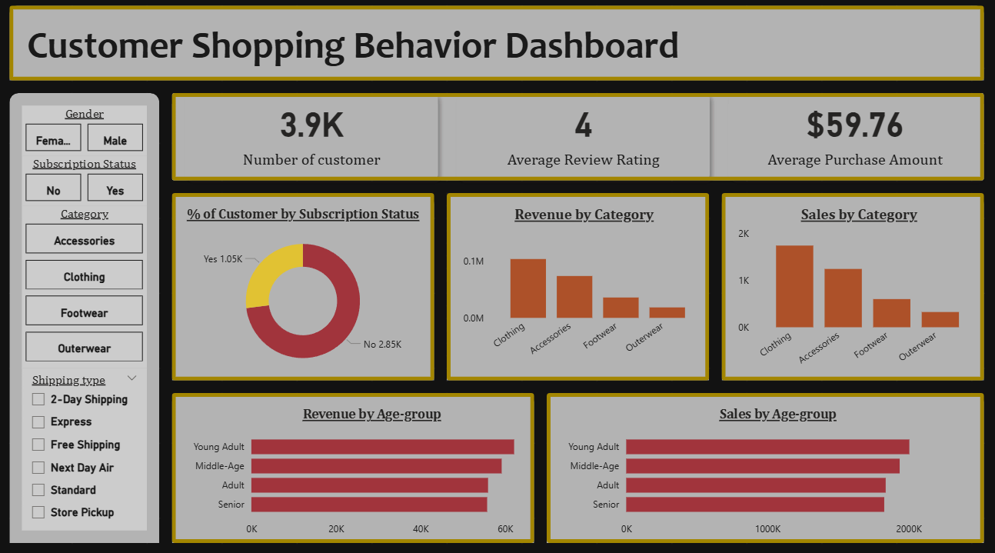

Key Metrics Highlighted
- Total Revenue: Overall revenue generated from all transactions
- Average Purchase Value: Approximately $59.76 per transaction
- Customer Distribution: Based on gender and age group
- Subscription Split: Subscribers vs Non-subscribers
- Top Categories: Based on revenue contribution

Dashboard Insights
- Young Adults contribute the highest revenue, making them the primary target segment
- Clothing is the top-performing category in terms of sales and revenue
- Average purchase value is around $59.76, indicating moderate spending behaviour
- Non-subscribers dominate the customer base, but subscribers spend more on average
- Discount usage is high, suggesting strong price sensitivity among customers
- Loyal customers contribute significantly to total revenue, despite being fewer in number

Summary
The dashboard highlights key revenue drivers, customer segments, and purchasing patterns, enabling data-driven business decisions.

Business Recommendations
• Target Young Adults aggressively through personalized marketing campaigns, as they contribute the highest revenue
• Promote subscription plans with benefits like discounts or free shipping to increase customer lifetime value
• Optimize discount strategies by focusing on high-value customers instead of mass discounts
• Introduce loyalty programs to retain returning and loyal customers
• Focus on top-performing categories (like Clothing) for inventory and marketing investment
• Bundle high-rated products to increase average order value

Conclusion
This project demonstrates how customer data can be leveraged to identify key purchasing patterns, customer segments, and revenue drivers.
The insights derived from SQL analysis and dashboard visualization can help businesses make data-driven decisions to improve customer targeting, optimize pricing strategies, and increase overall revenue.

